|  |
| --- |
| Beat Furrer (beat.furrer@uzh.ch), Urs Gamper (urs.gamper@uzh.ch), Leonahard Rüegg (leonhard.ruegg@uzh.ch) und Kim Whett (kim.whett@uzh.ch)  13.12.2019 |

|  |
| --- |
| Image Privacy Project – Final Report |
| A Python project conducted in the module “MATH101 Programming”  For PhD Candidate Maria Han Veiga (hmaria@physik.uzh.ch), IMATH-ICS, University of Zurich |

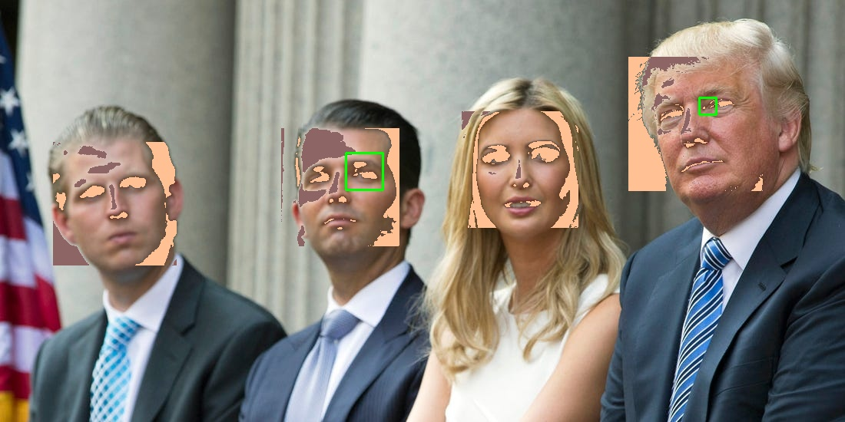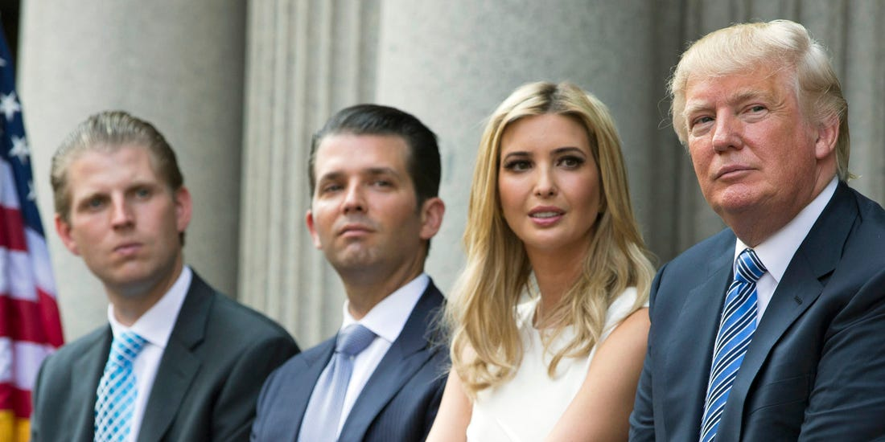

# Introduction

This project is motivated by the increase in the usage of automated image recognition algorithms (Parsania 2019). Especially China with its “Social-Credit-System” (SCS) drives this field of research. The SCS is national reputation system to monitoring its citizen and was developed by the Chinese government. In general, the SCs gives for each action of a citizen positive or negative points. Positives points can be collected by exemplary behaviour (e.g. to execute tax return in due time) and leads to social benefits (e.g. discount for the next train journey). Negative point can be collected as well (e.g. to drive over the crossing at red), but they can lead to harsh social consequences. If a person falls under a certain credit level due collecting too much negative points, the Chinese government is able to sanction the person (e.g. exclusion from public transport use). The usage of automated image recognition algorithms has not to end in a dystopia. A practical application is, for example, unlocking the screen by face.

A main goal in this project is to get a sense for face recognition. For this, the project is divided into seven tasks, which are conducted by different team members. Furthermore, the project is written in python and is based on the OpenCV package. Task 1 and 2 were done in group. They included to set up the structure of the code, implementing the received face detection algorithm and the validation of the algorithm. Task 3 was conducted by Kim Whett. The goal of this task was to improve the received face detection algorithm. Task 4 was conducted by Urs Gamper and included the measuring similarity between two pictures. Task 5 and 6 was conducted by Beat Furrer. First, a selective application of filters was set and second, adding at least one algorithm that leads to better blurring/ deblurring techniques or different filters. Finally, task 7 was conducted by Leonard Rüegg. This task contained to add a GUI that allows the user to load an image, apply filters, chose different face detectors and save the output.

As mentioned before, OpenCV package is used for the face recognition. OpenCV is an open source computer vison and machine learning software library (OpenCV 2019). In General, OpenCV has learnt due machine learning some facial characteristics. The software “considers adjacent rectangular regions at a specific location in a detection window, sums up the pixel intensities in each region and calculates the difference between these sums. This difference is used to categorize the subsections of an image” (Poudyal 2018). In other words, the software recognizes the bright and dark differences on a picture around our eyes. Usually it is darker at the height of our eyes than above and below as well beside our eyes to the check. When these characteristics occur, the software recognizes the face and will draw rectangles around the faces.

# Improving face detection algorithm (conducted by Kim Whett)

The improved face detection algorithm is not only based on the “haarcascade frontalface”, it is also based on the “haarcascade eye”. Both of them are trained files for detecting the face and eyes.

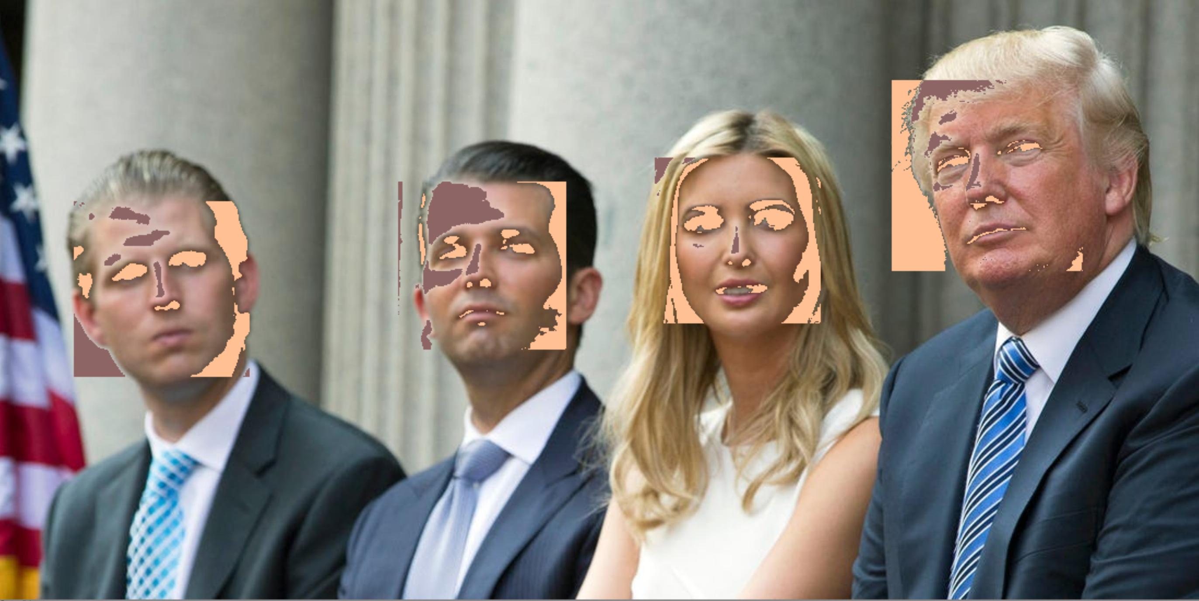

Figure 1: Test picture with filter and the received face detection

Figure 1 shows the test picture and the filter, which was developed by Beat Furrer and will be discussed in the following section. It is obvious that the received face detection does not recognize the faces of the subjects on the test pictures. The mentioned rectangles are not drawn around the faces. The filter is therefore good enough to outwit the face recognition algorithm.

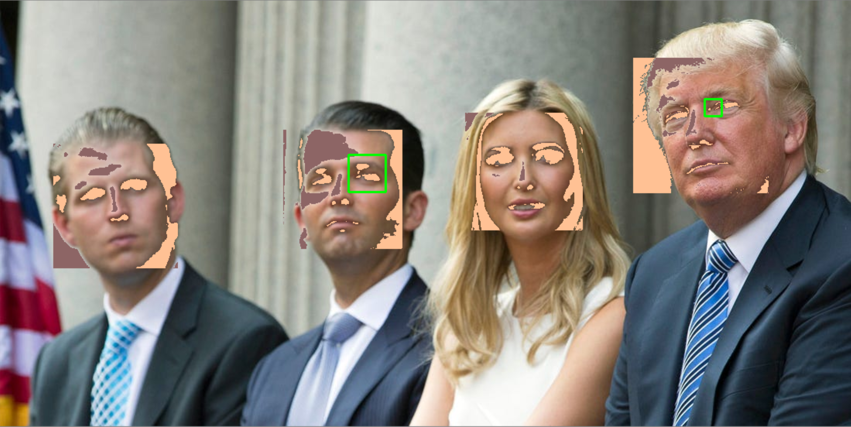

Figure 2: Test picture with filter and the improved face detection

Figure 2 displays the filter and the improved face detection. This detector can detect two eyes (green rectangles) in the filtered faces of the subjects. This underlines that the face detection has been improved.

In general, the eye detection recognizes eyes on a similar way as the face detection. A main criterion is that the area of an eye is darker than its surrounding. The Problem of this criterion is the high error rate, due to the high probability of darker areas with brighter surroundings. This is visualized in Figure 3. The eye detection is working by itself. This means with no further conditions.

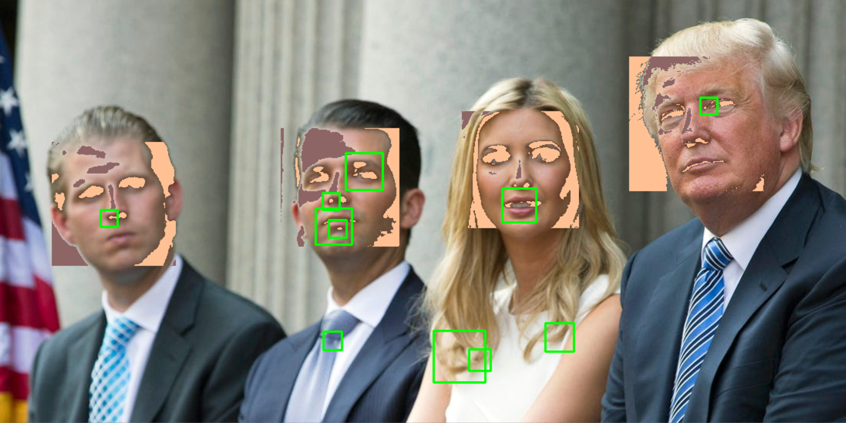

Figure 3: Test picture with filter and the self-standing eye detection

If the eye detector is not coupled to any condition, it recognized due to its high error rate several potential eyes, e.g. the tie of the second person from the left. To fix this problem the eye detector is linked to the following if-condition:

for (ex, ey, ew, eh) in eyes:

if (ex + ew) < (x + w) and (ey + eh) < (y + h):

cv2.rectangle(img, (ex, ey), (ex + ew, ey + eh), (0, 255, 0), 2)

else: print("eye not in face area detected")

Above is displayed a code-fragment from the class myFaceDetector2. If an eye is recognized in a picture the rectangle has to fulfil the if-condition. The coordinates of the eye-rectangle (ex, ey) as well as the hight and width of the eye-rectangle has to be in the face-rectangle. This is implemented by ex + ew < x + w and ey + eh < y + h. Other wise the statement “eye not in face area detected” is printed.

# Measuring similarity between pictures

# Selective application of filters

# Adding at least one algorithm that leads to better blurring/ deblurring techniques or different filters

# Add a GUI that allows the user to load an image, apply filters and save the output

# List of References

OpenCV (2019): *About*. https://opencv.org/about/. Access at 12.10.2019.

Parsania, Asieh (2019): MAT 101: *Programming. Group Projcet: Towards image privacy*. Universität Zürich: Zürich

Poudyal, Rabin (2018): *Real time face and eyes detection with OpenCV*. https://blog.goodaudience.com/ real-time-face-and-eyes-detection-with-opencv. Acess at 12.10.2019

# List of Figures

Figure 1: Test picture with filter and the received face detection 2

Figure 2: Test picture with filter and the improved face detection 2

Figure 3: Test picture with filter and the self-standing eye detection 3